Requirements Specifications

University Corridor Meeting Room and Workspace Reservation System

Team: - Syed Meesum raza Naqvi (24100183)

Student ID | Name
24100183 | Syed Meesum raza Naqvi

Table of Contents

1. Introduction 3
System Actors 4
2. Use Cases 5
2.1 Use Case Diagrams 5
2.2 Description of Use Cases 5
2.2.1 to 2.2.20 5
3. Class Diagram 16
3.1 Diagram 117
3.2 Description 18
4. Sequence Diagrams 22
4.1 to 4.20 22
5. State Diagrams 32
5.1 to 5.10 32
6. Non-functional Requirements / Quality Attributes 36
7. Who Did What? 37
8. Review checklist 37

Introduction

Overview:

The Workspace Reservation System is a web app designed to make it easier for people to book tables/workspaces in university department rooms. It’s built using modern technology of MERN stack (MongoDB, Express.js, React.js, Node.js), which helps it run smoothly and look simple to use. The system is made to help Teaching Assistants (TAs) and Coordinators manage workspaces in a way that is both organized and hassle-free.

Objectives:

- Make Booking Simple: The system makes it easy to find and reserve workspaces by showing what’s available and letting users search by date, time, and room number.
- Prevent Booking Issues: It ensures no two people can book the same table at the same time, which keeps things fair and avoids confusion.
- Clean Up Old Bookings: Past bookings are automatically deleted, which helps keep the system clean and easy to navigate.
- Support Different User Roles: There are separate features for TAs and Coordinators, which make sure everyone has the tools they need for their specific tasks.

Potential Users:

- Teaching Assistants (TAs): TAs can reserve up to two tables at a time, check their own bookings, and use FAQs for help when needed.
- Coordinators (Admins): Coordinators can book as many tables as they want, manage everyone’s reservations, create FAQs, and add or remove users.

This system is designed to save time and make managing shared spaces easier, which helps both users and administrators focus on their work without worrying about booking problems.

System Actors

Actor Name | Description
Teaching Assistant (TA) | A user who can reserve up to two tables at a time. TAs can view their bookings, cancel reservations, and access FAQs for guidance.
Coordinator (Admin) | A user with advanced permissions to book multiple tables, manage reservations for all users, create FAQs, and handle user accounts.
System | The application itself, which enforces rules like preventing double bookings, deleting past reservations, and ensuring data consistency.

Use Cases

Use Case Diagrams
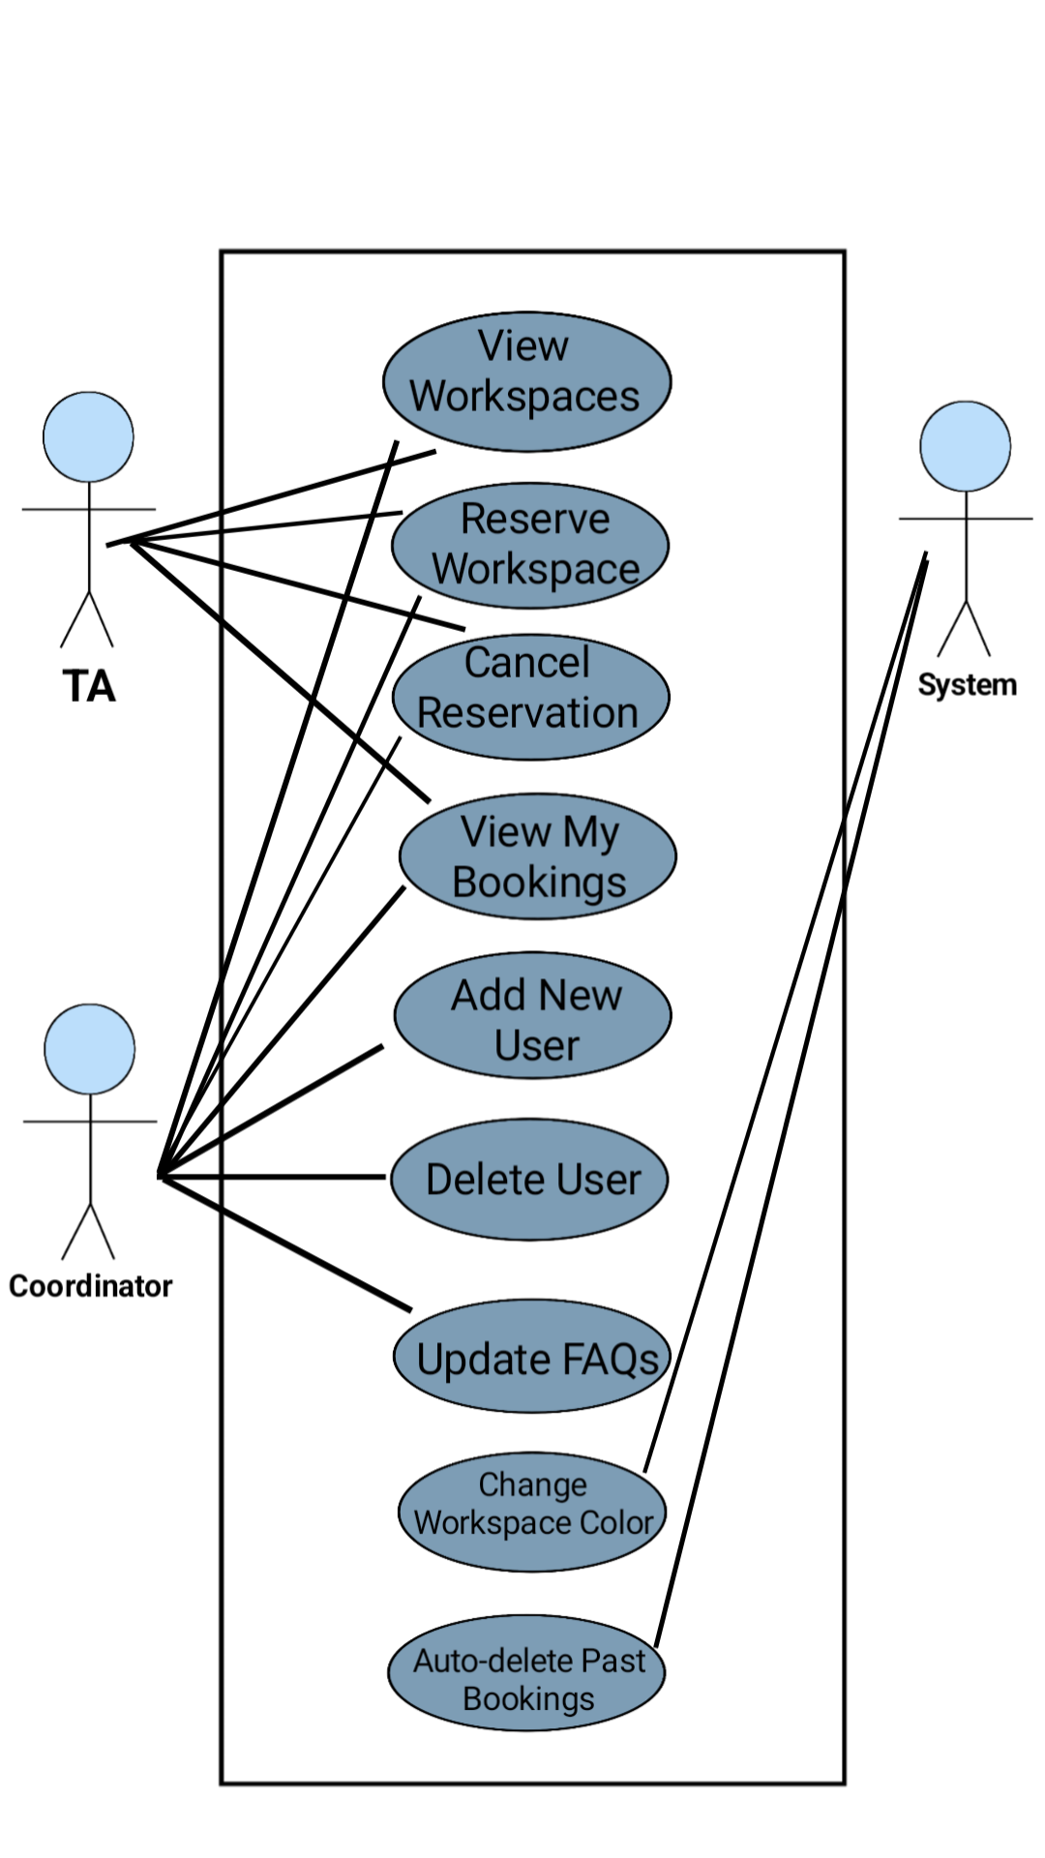

Description of Use Cases

View Available Workspaces

Identifier |  | UC-001
Purpose |  | Allow users to see all workspaces whether available or not.
Pre-conditions |  | User must be logged into the system.
Post-conditions |  | System displays a list of workspaces based on the user's criteria.
Step # | Typical Course of Action
 | User logs into the system.
 | User navigates to the 'Book Workspaces' page and see all workspaces there.
 | User searches based on criteria (date, time, room).
 | User inputs the criteria.
 | System displays workspaces accordingly.
Step # | Alternate Courses of Action
 | If the user does not select criteria, all available and unavailable workspaces of the next time slot are shown.
Step # | Exception Paths
 | User is not logged in, and the system redirects them to the login page.

Reserve a Workspace

Identifier |  | UC-002
Purpose |  | Enable users to reserve a workspace based on availability.
Pre-conditions |  | User must be logged in and workspace should be available.
Post-conditions |  | Workspace is reserved and marked as unavailable.
Step # | Typical Course of Action
 | User logs in and navigates to the 'Book WorkSpaces' page.
 | User selects an available workspace from the displayed list.
  User clicks 'Yes’ to confirm the booking.
 | System verifies the availability of the workspace.
 | System validates the reservation and updates the availability status.
Step # | Alternate Courses of Action
 | If the selected workspace is already reserved, the system displays “Already booked”.
Step # | Exception Paths
 | If the system fails to update the reservation, an error message is displayed.

Cancel a Reservation

Identifier |  | UC-003
Purpose |  | Allow users to cancel an existing reservation.
Pre-conditions |  | User must have an existing reservation.
Post-conditions |  | Reservation is canceled and marked as available.
Step # | Typical Course of Action
 | User navigates to 'View My Bookings'.
 | User selects a reservation and clicks 'Cancel'.
 | User selects the reservation to cancel.
 | System confirms the cancellation and updates availability.
 | System prompts “Booking cancelled successfully”.
Step # | Exception Paths
 | If the cancellation request fails, the system displays an error message.

View My Bookings

Identifier |  | UC-004
Purpose
  Allow users to view their current and upcoming reservations.
Pre-conditions |  | User must be logged in and have active reservations.
Post-conditions |  | User sees a list of their active reservations.
Step # | Typical Course of Action
  User logs in and navigates to the 'View My Bookings' page.
 | System fetches and displays the user’s reservations.
  User reviews the list of bookings.
Step # | Alternate Courses of Action
 | If no active reservations exist, the system displays a message: “No bookings found.”

Search Workspaces

Identifier |  | UC-005
Purpose
  Allow users to search for workspaces based on specific criteria.
Pre-conditions |  | User must be logged in.
Post-conditions
  Search results are displayed based on the criteria.
Step # | Typical Course of Action
 | User logs in and navigates to the 'Book WorkSpaces' page
 | User enters search criteria such as date, time, and room number.
 | User clicks 'Search'.
 | System filters and displays the matching results.
Step # | Alternate Courses of Action
 | If the user does not select criteria, all available and unavailable workspaces of the next time slot are shown.

Add New User (Admin)

Identifier |  | UC-006
Purpose |  | Enable Coordinators to add new users to the system.
Pre-conditions |  | Admin must be logged in with appropriate permissions.
Post-conditions |  | New user is added and can log in.
Step # | Typical Course of Action
 | Admin logs in and navigates to the 'Add User' page.
 | Admin enters user details (name, email, role).
 | Admin submits the form.
 | System validates inputs and adds the user.
Step # | Alternate Courses of Action
 | If user details are incomplete, the system prompts for corrections.
Step # | Exception Paths
 | If the system cannot create the user, an error message is shown.

Delete User (Admin)

Identifier |  | UC-007
Purpose |  | Allow Coordinators to delete user accounts.
Pre-conditions |  | Admin must be logged in with appropriate permissions.
Post-conditions |  | User account is removed from the system.
Step # | Typical Course of Action
  Admin logs in and navigates to the 'User Records' page.
  Admin selects a user and clicks on Delete Icon and confirms deletion.
 | System confirms the action and deletes the user.
Step # | Alternate Courses of Action
 | If deletion fails, the system displays an error message.

Delete FAQs (Admin)

Identifier |  | UC-008
Purpose |  | Allow Coordinators to create and delete FAQs visible to users.
Pre-conditions |  | Admin must be logged in.
Post-conditions |  | FAQs are deleted or created and displayed to users.
Step # | Typical Course of Action
 | Admin navigates to the 'FAQs' page.
 | Admin adds FAQ content (question and its answer).
 | Admin confirms by clicking on ‘Add Question’ button, and the system updates the FAQ list.
Step # | Alternate Courses of Action
 | If FAQs are not saved due to invalid input, the system prompts corrections.

Cancel Booking (Admin)

Identifier |  | UC-009
Purpose |  | Allow Coordinators to cancel bookings for any user.
Pre-conditions |  | Admin must have access to user bookings.
Post-conditions
  Booking is cancelled and marked as available.
Step # | Typical Course of Action
 | Admin navigates to the 'View All Upcoming Bookings' page.
 | Admin selects a booking and clicks 'Cancel'.
 | System confirms cancellation and updates availability.
Step # | Alternate Courses of Action
  If booking cannot be cancelled, the system notifies the admin.

Authenticate User

Identifier |  | UC-010
Purpose |  | Ensure only valid users can access the system.
Pre-conditions
  User must provide valid credentials.
Post-conditions |  | User gains access to the system.
Step # | Typical Course of Action
  User enters email and password on the login page.
 | System validates credentials.
  User is redirected to the dashboard if authentication is successful.
Step # | Alternate Courses of Action
 | If credentials are invalid, the system displays an error message.

Logout User

Identifier |  | UC-011
Purpose |  | Allow users to securely log out of the system.
Pre-conditions |  | User must be logged in.
Post-conditions |  | User is logged out, and their session is terminated.
Step # | Typical Course of Action
 | User clicks the 'Logout' button from the side menu on the dashboard.
 | System ends the user session and redirects them to the login page.
Step # | Alternate Courses of Action
 | If the session is already expired, the system redirects to the login page automatically.

View User Records (Admin)

Identifier |  | UC-012
Purpose |  | Allow Coordinators to view all registered user accounts.
Pre-conditions |  | Admin must be logged in.
Post-conditions |  | User details are displayed in the records.
Step # | Typical Course of Action
 | Admin navigates to the 'User Records' page.
 | System fetches and displays all user accounts.
Step # | Alternate Courses of Action
 | If no users are registered, the system displays: “No user records found”

Prevent Double Booking

Identifier |  | UC-013
Purpose |  | Ensure no two users can book the same workspace at the same time.
Pre-conditions
  User or Admin must attempt to book a workspace.
Post-conditions |  | Booking conflicts are avoided, and availability is updated.
Step # | Typical Course of Action
 | User selects a workspace and initiates a reservation.
 | System checks the workspace availability.
 | If available, the system confirms the booking.
Step # | Alternate Courses of Action
 | If the workspace is already booked, the system displays: “Already booked”
Step # | Exception Paths
 | If the availability check fails, the system shows an error message.

Real-time Updates for Availability

Identifier |  | UC-014
Purpose |  | Provide users with real-time updates on workspace availability.
Pre-conditions |  | System must be operational and synchronized with the database.
Post-conditions |  | Workspace availability is updated dynamically.
Step # | Typical Course of Action
 | User navigates to the 'Book Workspaces' page.
  System fetches and updates workspace statuses in real time.
Step # | Alternate Courses of Action
 | If real-time updates fail, the system displays cached data and a warning.
Step # | Exception Paths
 | If the connection to the database fails, the system notifies the user.

Auto-delete Past Reservations

Identifier |  | UC-015
Purpose |  | Automatically remove expired bookings to maintain a clean database.
Pre-conditions |  | System must run a conditioned cleanup process.
Post-conditions |  | Expired bookings are removed from the database.
Step # | Typical Course of Action
  System checks for bookings with past dates.
 | System removes expired reservations.
Step # | Alternate Courses of Action
 | If no past bookings are found, the system completes the process without action.

Edit User Profile

Identifier |  | UC-016
Purpose |  | Allow users to update their personal information.
Pre-conditions |  | User must be logged in.
Post-conditions |  | User details are updated in the system.
Step # | Typical Course of Action
 | User navigates to the 'My Account' page.
 | User updates their name or email and submits the form.
 | System validates the changes and updates the database.
Step # | Alternate Courses of Action
  If validation fails, the system notifies the user to correct input.

Manage Bookings for Others (Admin)

Identifier |  | UC-017
Purpose |  | Allow Coordinators to manage bookings for other users.
Pre-conditions |  | Admin must have access to all bookings.
Post-conditions |  | Bookings are cancelled as needed.
Step # | Typical Course of Action
 | Admin navigates to the 'View All Upcoming Bookings' page.
 | Admin selects a user’s booking and cancels it.
 | System updates the booking accordingly.
Step # | Exception Paths
 | If the update fails, an error message is displayed.

Display FAQs

Identifier |  | UC-018
Purpose |  | Provide users with frequently asked questions for guidance.
Pre-conditions |  | FAQs must be added by the Admin.
Post-conditions |  | FAQs are displayed to users.
Step # | Typical Course of Action
 | User navigates to the 'FAQs' page.
 | System fetches and displays the list of FAQs.
Step # | Alternate Courses of Action
  If no FAQs are available, the system displays: “No FAQs found”

Change Workspace Color Based on Booking Status

Identifier |  | UC-019
Purpose |  | Update workspace color to reflect booking status (reserved or available).
Pre-conditions |  | User must confirm or cancel a booking.
Post-conditions |  | Workspace color changes to red (reserved) or green (available).
Step # | Typical Course of Action
 | User reserves a workspace by completing the booking process.
 | System updates the workspace status in the database.
 | Workspace color changes to red, indicating it is reserved.
 | If the user cancels the booking, the system updates the status.
 | Workspace color changes back to green, indicating it is available.

Reset Password

Identifier |  | UC-020
Purpose |  | Allow users to update their password securely within the "My Account" page.
Pre-conditions |  | User must be logged in and know their current password.
Post-conditions |  | User's password is updated in the system based on the password rules.
Step # | Typical Course of Action
 | User logs into the system and navigates to the "My Account" page.
 | User goes to the "Password" section.
 | User enters their current password, new password, and confirms the new password.
System validates the entered passwords based on the rules:
- Minimum of 8 characters
- At least one number
- At least one special character
- At least one uppercase letter
- At least one lowercase letter.
 | If the validation is successful, the system updates the password and displays a success message.
Step # | Exception Paths
 | If validation fails (e.g., password rules not met or incorrect current password), the system notifies the user with appropriate error messages.

Class Diagram

Diagram

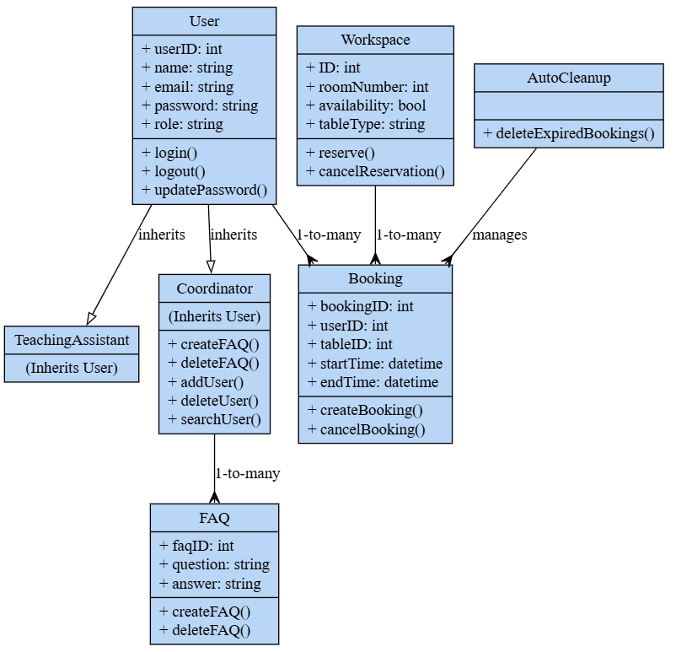

Description

Classes and Descriptions

- User
Description: Represents the base class for all users in the system, including both Teaching Assistants and Coordinators. Provides common attributes and functionalities for managing user authentication and profile updates.
Attributes:
  - userID: Unique identifier for the user.
  - name: Name of the user (including First and Last Name).
  - email: User's email address for login and communication.
  - password: Encrypted password for secure authentication.
  - role: Role of the user (e.g., TA or Coordinator).
Operations:
  - login(): Authenticates the user and grants access to the system.
  - logout(): Logs the user out of the system.
  - updatePassword(): Updates the user's password based on provided input.

- TeachingAssistant
Description: Inherits from the User class. Represents a Teaching Assistant with permissions to view, reserve, and cancel bookings for workspaces.
Purpose: Focuses on workspace usage functionalities for Teaching Assistants.
Attributes and Operations: Inherits all from User.

- Coordinator
Description: Inherits from the User class. Represents a Coordinator (Admin) with administrative permissions, including managing users, FAQs, and workspace bookings.
Attributes and Operations:
  - Inherits all attributes from User.
  - Additional Operations:
    - createFAQ(): Adds a new FAQ entry.
    - deleteFAQ(): Removes an FAQ from the system.
    - addUser(): Adds a new user to the system.
    - deleteUser(): Deletes an existing user account.
    - searchUser(): Searches for a user in the system.

- Workspace
Description: Represents a workspace or table within a room. Tracks availability and allows reservation or cancellation of bookings.
Attributes:
  - ID: Unique identifier for the workspace.
  - roomNumber: The room in which the workspace is located.
  - availability: Indicates if the workspace is available (true/false).
  - tableType: Type of table (e.g., 1-seater, 2-seater).
Operations:
  - reserve(): Reserves the workspace for a booking.
  - cancelReservation(): Cancels the workspace reservation.

- Booking
Description: Tracks reservations made by users. Stores details like the booked workspace, timing, and the user who made the reservation.
Attributes:
  - bookingID: Unique identifier for the booking.
  - userID: Identifier of the user who made the booking.
  - tableID: Identifier of the reserved workspace.
  - startTime: Start time of the reservation.
  - endTime: End time of the reservation.
Operations:
  - createBooking(): Creates a new reservation in the system.
  - cancelBooking(): Cancels an existing reservation.

- FAQ
Description: Stores frequently asked questions and answers visible to users. Managed by Coordinators.
Attributes:
  - faqID: Unique identifier for the FAQ entry.
  - question: Text of the FAQ question.
  - answer: Text of the FAQ answer.
Operations:
  - createFAQ(): Adds a new FAQ to the system.
  - deleteFAQ(): Deletes an FAQ.

- AutoCleanup
Description: Manages system automation to maintain database integrity by removing outdated bookings.
Attributes:
  - No specific attributes as its purpose is functional.
Operations:
  - deleteExpiredBookings(): Automatically deletes bookings that are no longer valid.

Sequence Diagrams

Use case Name: View Available Workspaces

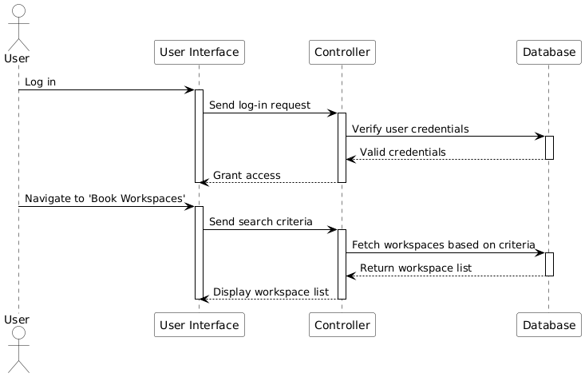

Use case Name: Reserve a Workspace

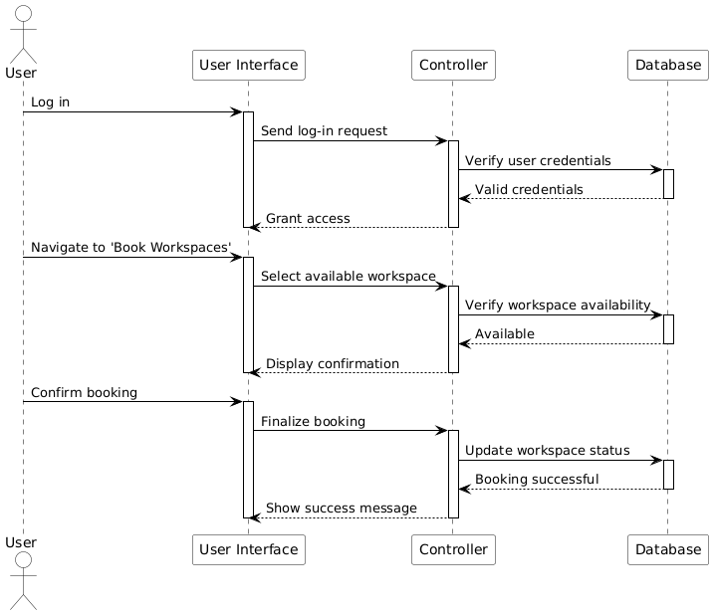

Use case Name: Cancel a Reservation

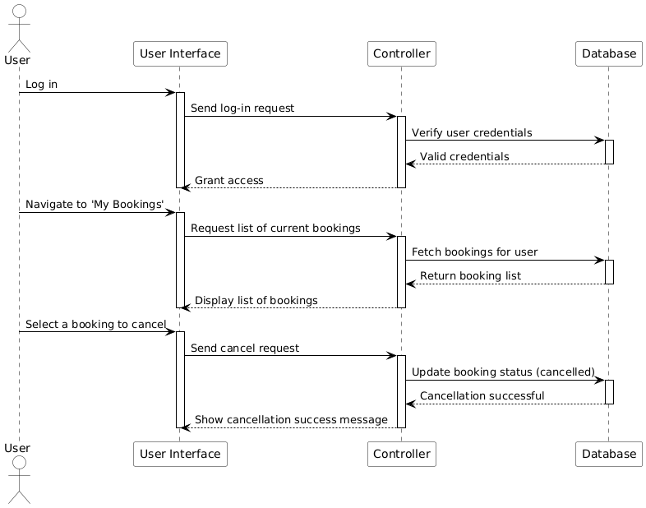

Use case Name: View My Bookings

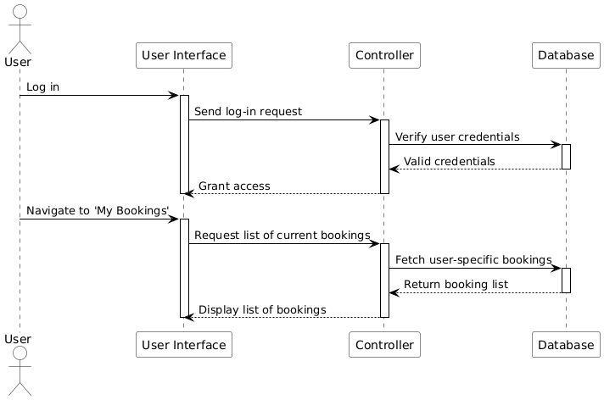

Use case Name: Search Workspaces

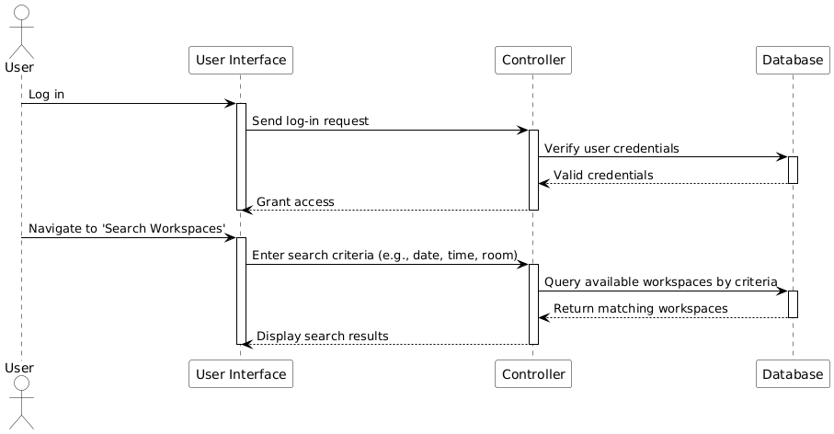

Use case Name: Add New User (Admin)

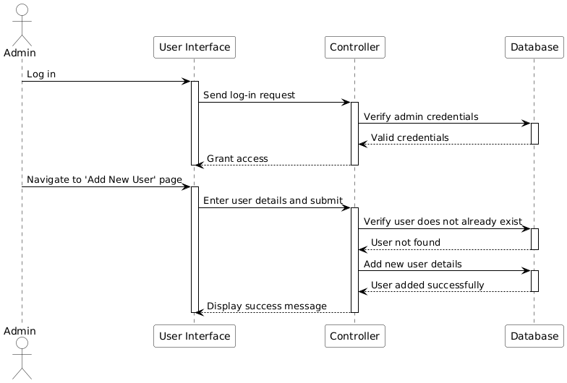

Use case Name: Delete User (Admin)

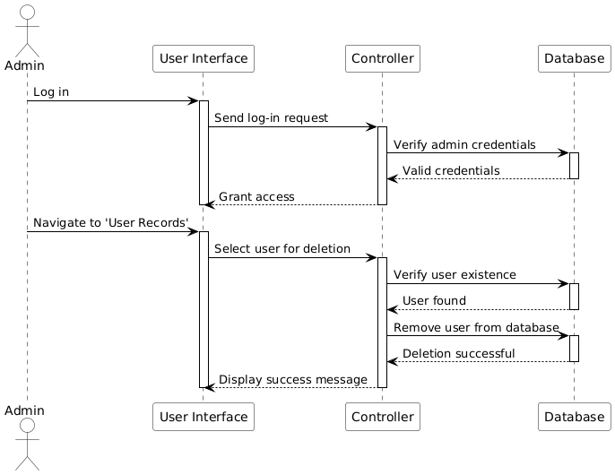

Use case Name: Delete FAQs (Admin)

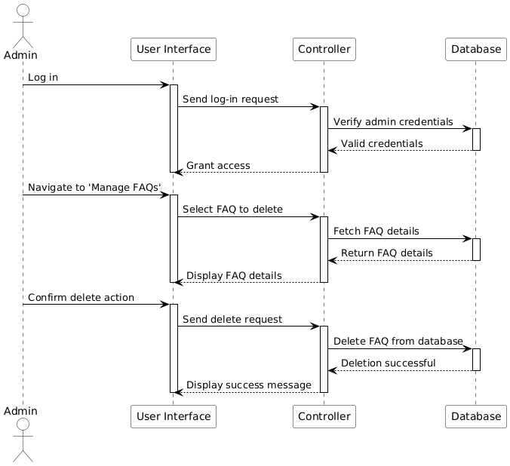

Use case Name: Cancel Booking (Admin)

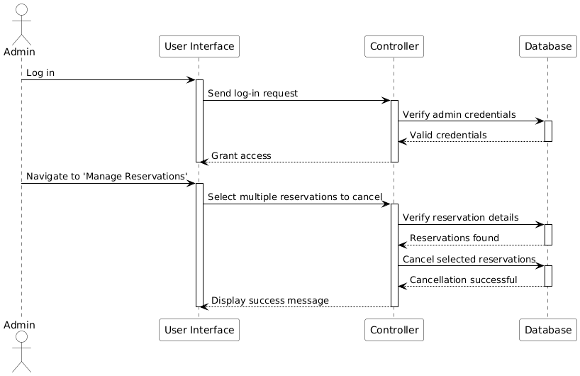

Use case Name: Authenticate User

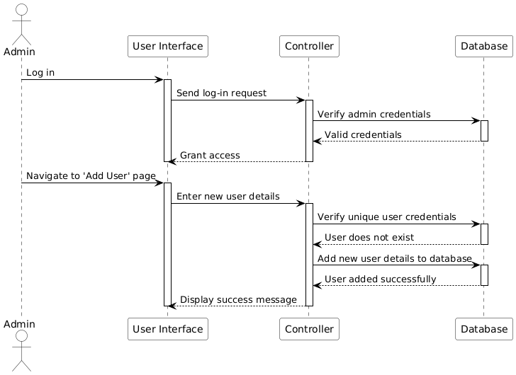

Use case Name: Logout User

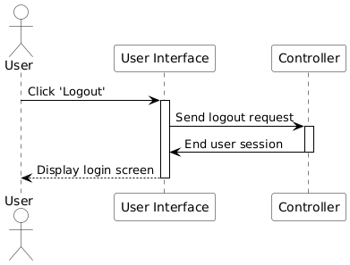

Use case Name: View User Records (Admin)

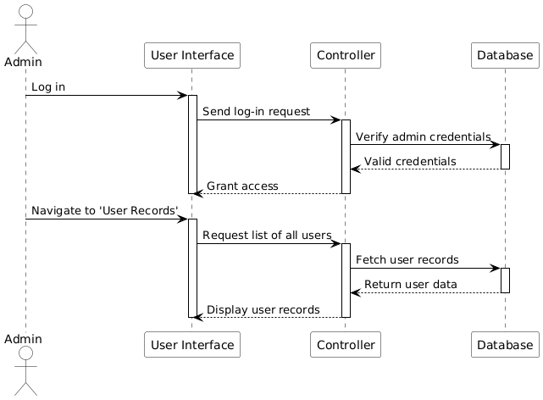

Use case Name: Prevent Double Booking

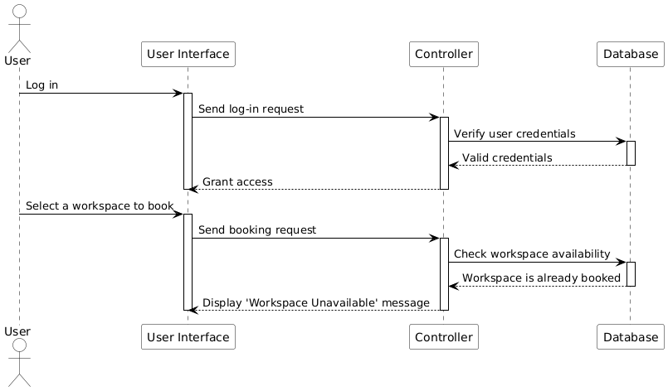

Use case Name: Real-time Updates for Availability

Use case Name: Auto-delete Past Reservations

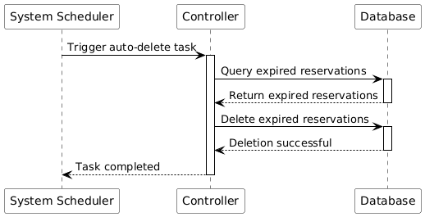

Use case Name: Edit User Profile

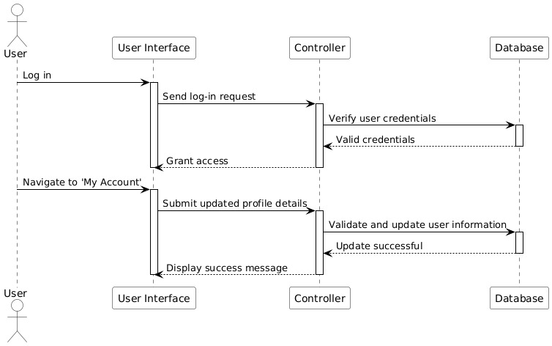

Use case Name: Manage Bookings for Others (Admin)

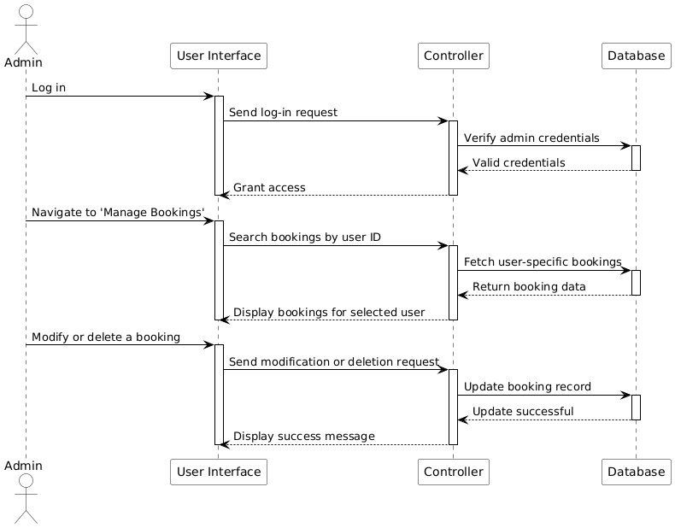

Use case Name: Display FAQs

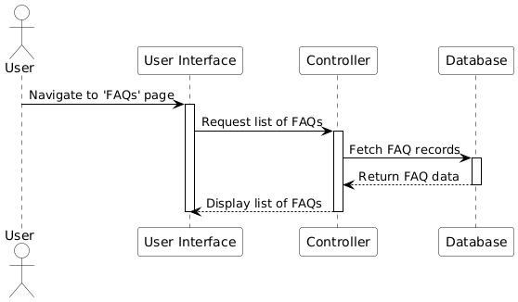

Use case Name: Change Workspace Color Based on Booking Status

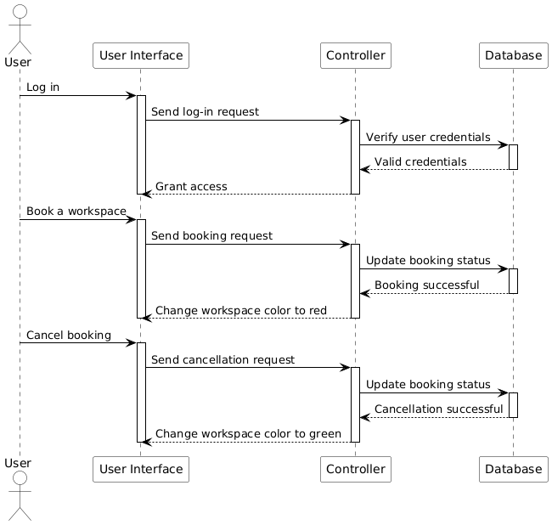

Use case Name: Reset Password

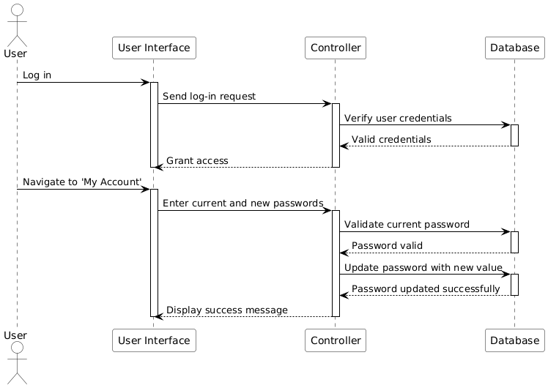

State Diagrams

Diagram details

Name: Workspace Search State Diagram
Description:
This state diagram describes the process a user undergoes while searching and managing the availability of workspaces in the system. It captures the transitions and states involved in initiating, processing, and finalizing a workspace search.

States:
- Idle:
  - The system is inactive. The user has not initiated any action.
  - Example: The application is launched, but no workspace search has begun.
- Searching:
  - The user initiates a workspace search, and the system is processing their request.
  - Example: The user enters search criteria, and the system is retrieving available workspaces.
- Available:
  - A workspace matching the user's criteria is found. The user can confirm the booking.
  - Example: The system displays a list of available workspaces to the user.
- Unavailable:
  - No workspace matching the user's criteria is found. The user is informed of unavailability.
  - Example: The system notifies the user that no workspaces are available for the selected criteria.
- Reserved:
  - The user confirms a booking, and the workspace is successfully reserved.
  - Example: The system finalizes the reservation for the selected workspace.
- Cancelled:
  - The user cancels the booking after confirming it.
  - Example: The system releases the reserved workspace for other users.

Transitions:
- From Idle to Searching:
  - Trigger: User initializes a workspace search.
  - Example: The user selects the search option and enters workspace preferences.
- From Searching to Available:
  - Trigger: The system finds workspaces based on the entered criteria.
  - Example: The search query returns one or more available workspaces.
- From Searching to Unavailable:
  - Trigger: No workspaces are found matching the criteria.
  - Example: The user is notified that no results match their search.
- From Available to Reserved:
  - Trigger: The user confirms the booking of a selected workspace.
  - Example: The user clicks "Confirm" after selecting an available workspace.
- From Reserved to Cancelled:
  - Trigger: The user cancels the confirmed booking.
  - Example: The user decides to release the reservation for unforeseen reasons.
- From Unavailable to Idle:
  - Trigger: The user chooses to return to the home page or restart the search.
  - Example: The user selects the "Home" button after seeing the unavailability message.

Diagram

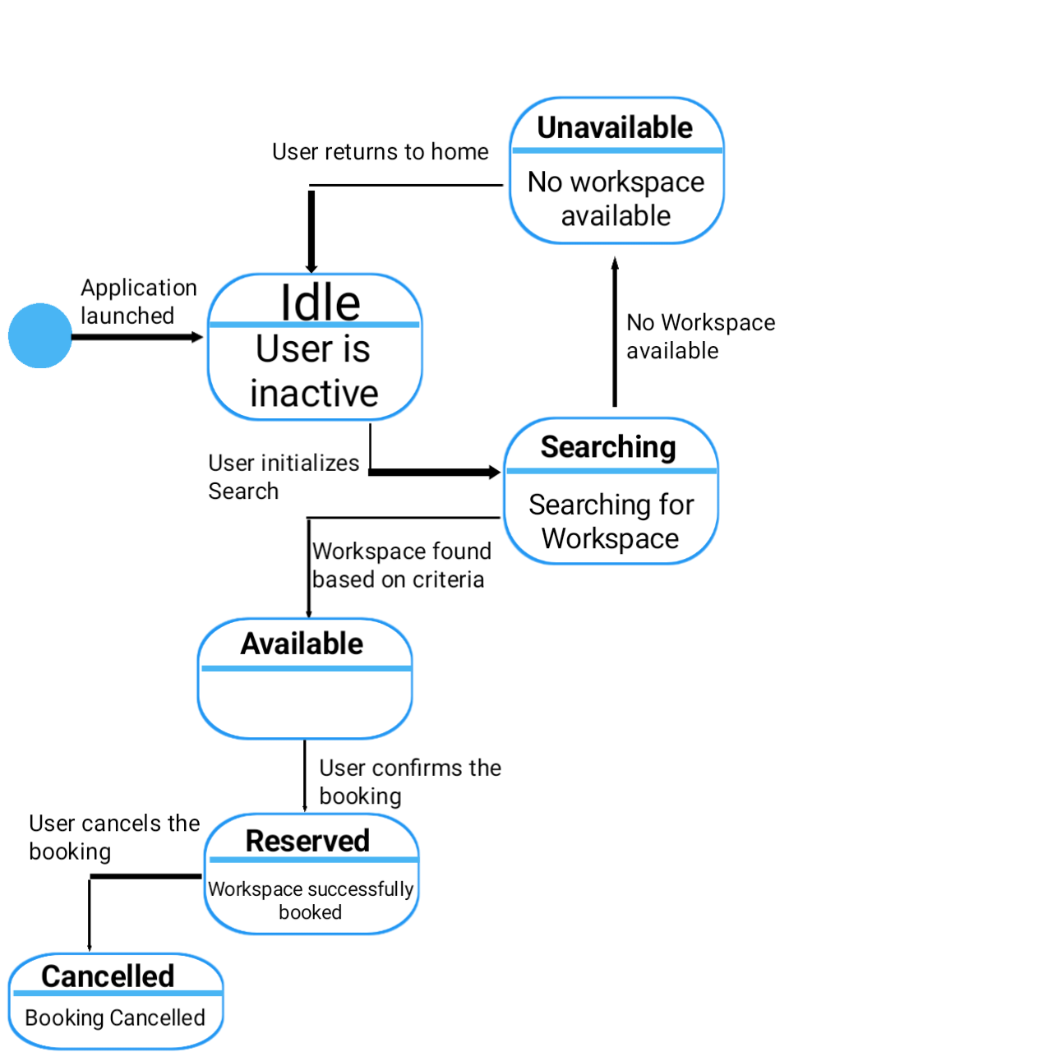

Non-functional Requirements / Quality Attributes

Sr# | Requirements
1 | The system should load the dashboard within 3 seconds after login to ensure a smooth user experience.
2 | The system should be available for use more than 98% of the time to ensure reliability for users.
3 | The system should provide real-time updates for table availability with a delay of no more than 4 seconds.
4 | The system should use less than 1 GB of memory during normal operation.

Who Did What?

Name of the Team Member | Tasks done
Syed Meesum Raza Naqvi
  Introduction, System Actors, Use Cases, Class Diagram, Sequence Diagrams, State Diagrams, Non-Functional Requirements.

Review checklist

Section Title | Reviewer Name(s)
Introduction | Syed Meesum Raza Naqvi
System Actors | Syed Meesum Raza Naqvi
Use Cases | Syed Meesum Raza Naqvi
Class Diagram | Syed Meesum Raza Naqvi
Sequence Diagrams | Syed Meesum Raza Naqvi
State Diagrams | Syed Meesum Raza Naqvi
Non-Functional Requirements | Syed Meesum Raza Naqvi

